APPENDIX A
PHOTOGRAPHS TAKEN DURING JIV AT 18” OBAMA-BRASS PIPELINE AT GOLUBOKIRI COMMUNITY, NEMBE L.G.A, BAYELSA STATE ON 29TH MARCH, 2024.
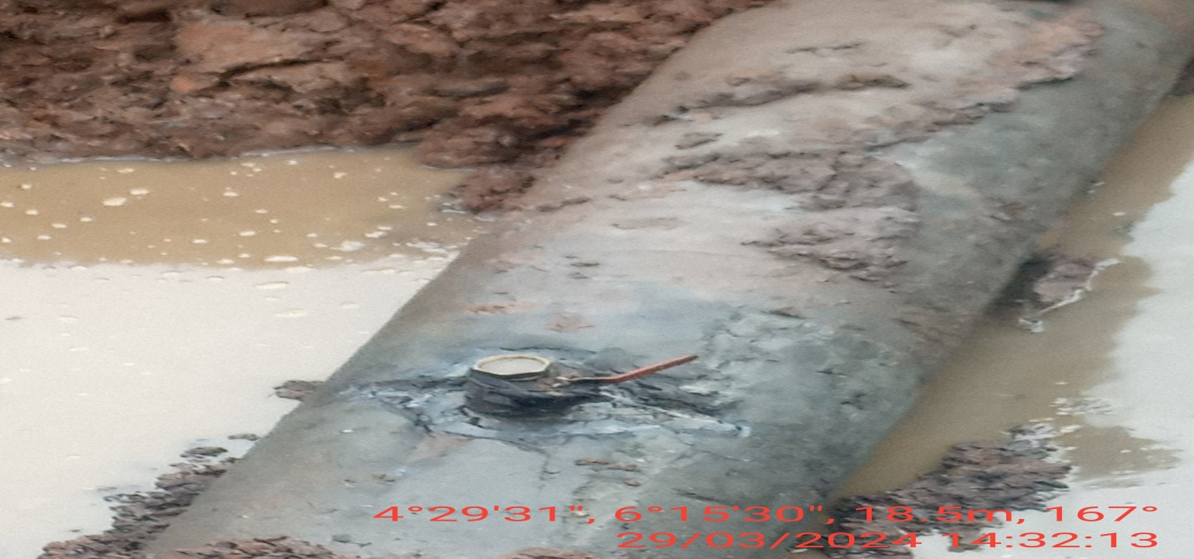
Fig. 1: 2” valve installed at 12 o’ clock position of the pipeline for crude oil theft activity by Vandals.
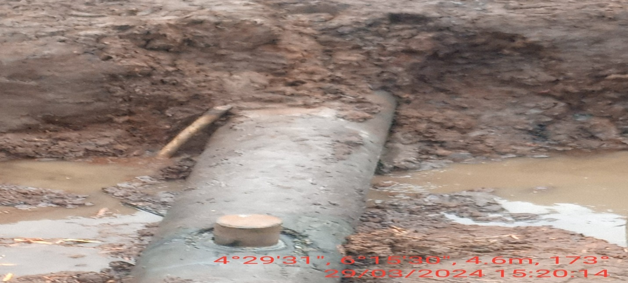
Fig. 2: The incident point after repair has been done.

